Mapping Synchronization Tutorial

# Introduction

This document contains the step-by-step process to synchronize the **Mapplet-Property** and edit **Parameters** on each mapping. In specific on the Donaldson EDW Sil Mappings IICS file.

Index

Introduction 1

Setting Up 3

Example of Search 5

In the Mapping 6

Synchronizing a Mapplet 7

Editing Mapping Parameters 9

Saving Mapping Changes 11

# Setting Up

* Once logged in to the browser tool (IICS) the user must choose the Data-Integration option on the first panel (My services) as shown in the image below.  
  Graphical user interface, website

  Description automatically generated
* If the user is already logged in, the user must click on the down arrow shown in the top-left of the screen as shown in the image below.  
  Graphical user interface, text

  Description automatically generated
* When clicking it the user might see the first image panel (My Services) and the Data-Integration option.
* On the top left, the user will see three bluish bars. Left-clicking on those will get to the “tab-bar” and allow the user to open de “Explorer” tool to navigate between the [IICS] file library.

* This way the user can write on the “Find” white bar located on the top-left of the screen to look for the map the user wants to synchronize like the image below and type the name of the mapping the user wants to find.

# Example of Search

In this case:

The Mapping **SIL_CostCenterDimension** to find.

**But the user can search all kinds of files within the User-Role permissions the user account is assigned.**

Opening, seeing, and editing.

It can be organized by *Name* – *Type* – *Last Update* (Updated On) – *What file is it located* (Location) and by Its *Description,* as the user can see above.

# In the Mapping

Once the user has clicked on the desired mapping. It will show the chosen Mapping on the top left right under “My Import/Export Logs”.

And it will be opened on screen like this one:

# Synchronizing a Mapplet

To actually synchronize for example:  
Start choosing any Mapplet the user want to Synchronize and click on it for example:  
The **mplt_Get_Etl_Proc_Wid** Mapplet right-clicked.

* After, click on the Properties bar that will open on the left side of the screen.
* Once it does the user will need to select the “*Property-Option”* **Mapplet** And right-click on **Synchronize** to do the *sync*.

Like the image below:

# Editing Mapping Parameters

To edit a Mapping Parameter:

* The user must click on the top-left icon named **Parameter**



* Once the user right-clicks it. A big window called Parameters will open. The user will be able to see all **In and Out parameters**. And all their names subsequentially on the right side of the mapping. Like the image below.

To edit a **Paramete**r:

* The user must choose one and right-click it:  
  ]

Editing “**mplt_SIL_CostCenterDimension_SOURCE_CODE_NOT_SUPPLIED**” Parameter for example. This window will pop-up listing the **Parameter-Specifications.**

**Name – Description – Data-Type – Precision – Scale –** If it is an “**Expression Variable**” or not **–** The “**Default Value**” for the Parameter – It’s “**Retention Policy”** and “**Aggregation Type”**.

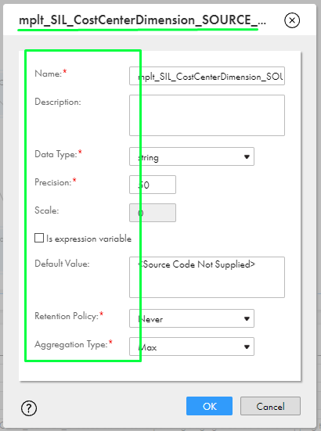

In this case:

* The user is changing the name to “**SOURCE_CODE_NOT_SUPPLIED2**”.Text

  Description automatically generated with medium confidence
* And if the name has already been used in any other parameter this message might be shown in red under the chosen name:

* Once the changes are done. The user must click OK at the end of the page to make the change.  
  Diagram

  Description automatically generated with medium confidence

# Saving Mapping Changes

To finish the changes must be saved.

* The user must be finished with all the changes the user had to do, then **Save** the mapping by clicking on the **SAVE** top blue icon.   
  Just like the image below:

This way the mapping will be updated and re-written on the filesystem.

* To make sure the user can check its “**Updated-on**” date before and after on the “**Explore”** tool again like the sample below.

**Before:** 

**After:**

